|  |
| --- |
| LIBRARY USED |
| FUNCTION USED |
| TOPIC  USE  SELECT  SELECT DISTINCT  FROM  JOIN cust ON id=id |
| REMEMBER THIS  Operator    WHERE :  IN  Between  Like ‘b%’ : trump  Like ‘_y’ :exact  WHERE REGEXP  ‘^FIELD’ : ^ MUST START WITH FIELD  ‘FIELD$’; END WITH FIELD  ‘FIELD|mac|ROSE’; EITHER ONE  '[gim]E' : ge or ie, or me  [a-h]e: ae, be, ce,… **with leftside hyphen |
| EXPRESSION EXAMPLE  SELECT  first_name,  last_name,  points,  (points + 100) * 10 AS "discount factor"  FROM customers  SELECT *  FROM customers  ORDER BY first_name DESC  Self-join:  SELECT  e.employee_id,  e.first_name,  m.first_name AS manager  FROM employees e  JOIN employees m  ON e.reports_to = m.employee_id |

NOTE:

Clause: operation

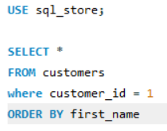

Syntax is important. Need to be in order. Here is the list

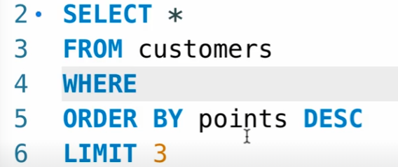

Operator